ATESL 2018 Conference
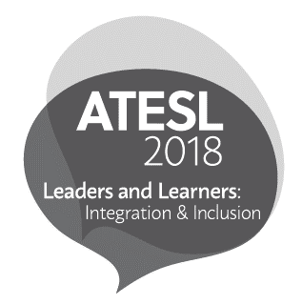
ATESL
6-102 Education North
University of Alberta
Edmonton, AB
T6G 2G5

April 24, 2018

Dear Publishers and Exhibitors,

We would like to take this opportunity to invite your organization to participate in the Publishers and Exhibitors Display at this year’s ATESL Conference.

The ATESL 2018 Conference is taking place Friday, October 12, 2018 and Saturday, October 13, 2018 at the Fantasyland Hotel in Edmonton, Alberta. The theme of this year’s conference is Leaders and Learners: Integration & Inclusion. We are very honoured to welcome keynote speakers Dr. Ingrid Johnston, University of Alberta; Dr. Jennifer Foote,University of Alberta; and Author and Inspirational Speaker, Michel Chikwanine.

We are anticipating approximately 360 participants at this year’s conference and we believe that the Publishers and Exhibitors Display is an integral part of our conference. It offers Alberta’s ESL teachers an array of innovative materials and resources that they can incorporate into their classrooms throughout the province.

Please find attached the Publishers and Exhibitors Display Registration Form. Please complete the form, and submit an electronic copy as soon as possible to guarantee your spot at this year’s conference.

If you have any questions, please feel free to contact me at publishers@atesl.ca

I look forward to seeing you at the conference.

Sincerely,

Ping Ping Lee
Publishers and Exhibitors Display Committee

